**Project Design Phase-II**

**Data Flow Diagram & User Stories**

|  |  |
| --- | --- |
| Date | 03 October 2022 |
| Team ID | PNT2022TMIDxxxxxx |
| Project Name | Project - xxx |
| Maximum Marks | 4 Marks |

**Data Flow Diagrams:**

A Data Flow Diagram (DFD) is a traditional visual representation of the information flows within a system. A neat and clear DFD can depict the right amount of the system requirement graphically. It shows how data enters and leaves the system, what changes the information, and where data is stored.

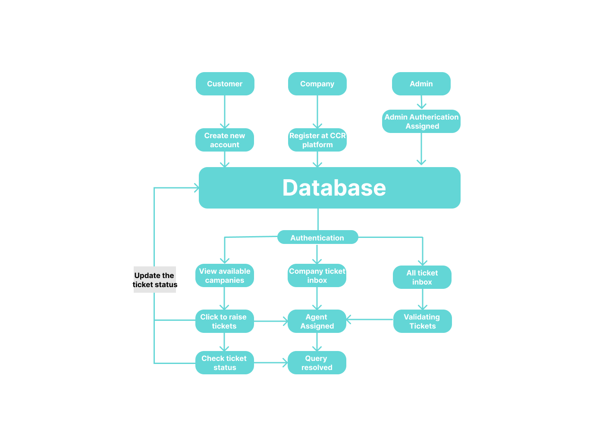

**User Stories**

Use the below template to list all the user stories for the product.

| **User Type** | **Functional Requirement (Epic)** | **User Story Number** | **User Story / Task** | **Acceptance criteria** | **Priority** | **Release** |
| --- | --- | --- | --- | --- | --- | --- |
| Customer (Mobile user) | Registration | USN-1 | As a user, I can register for the application by entering my email, password, and confirming my password. | I can access my account / dashboard | High | Sprint-1 |
|  |  | USN-2 | As a user, I will receive confirmation email once I have registered for the application | I can receive confirmation email & click confirm | High | Sprint-1 |
|  |  | USN-3 | As a user, I can register for the application through Google. | I can register & access the dashboard with Google Login | Low | Sprint-2 |
|  |  | USN-4 | As a user, I can register for the application through Gmail | I can register through my gmail account | Medium | Sprint-1 |
|  | Login | USN-5 | As a user, I can log into the application by entering email & password | I can access my account without integrations | High | Sprint-1 |
|  | Dashboard | USN-6 | As a user I should be able to navigate and access all the features hassle free | The UI is clear with all features and apt theme | Medium | Sprint-1 |
| Customer (Web user) | Layout | USN-7 | As a user I should be able to access the portal with different devices with the same comfort | I can access the portal through all my devices | Medium | Sprint-1 |
| Customer ticket service Executive | User Segregation and data access | USN-8 | As CTS executive I should be able to resolve tickets and priorities the tickets based on ticket status | I can resolve customer tickets through agents and assign and update ticket status | High | Sprint-3 |
| Administrator | Validating tickets | USN-9 | As a admin I should be able to monitor the raised tickets and safeguard customer’s from spam. | I can remove spam tickets and validate raised tickets | Medium | Sprint -2 |
|  | Change code | USN-10 | As a administrator I should be able to fix errors before its affects the user experience. | I can fix bugs and maintain a smooth user experience. | Medium | Sprint-2 |
|  | Assign chat services | USN-11 | When the agent Is assigned the chat service should also be established | I can assign a chat service for the agent and customer to better communicate. | High | Sprint-3 |